UNIT 1

POINTS OF SAILING

Courses of a sailboat relative to the direction of the wind; the sailboat navigates portside or starboard side, depending on which side the wind is coming from.

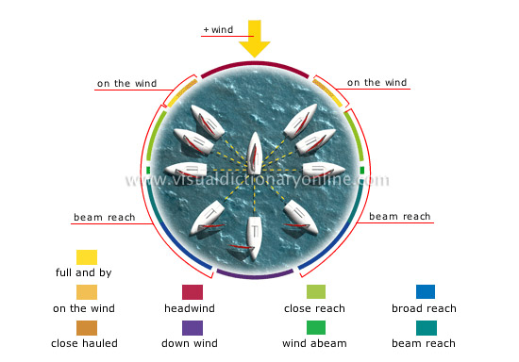

Wind
Displacement of air caused by variations in pressure between two regions of the atmosphere.

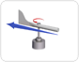

SAILING AND COURSE

Starboard
Sailing with the wind coming over the starboard side of the vessel; as in: "A sailboat on a starboard tack has the right of way."

On the wind
Points of sailing in between a headwind and a close reach that are used especially when tacking; the sails are near the boat’s centerline.

Close hauled
Point of sailing of a sailboat traveling near the wind’s eye (axis), with its sail at an angle of about 45°; close hauled is the limit of sailing against the wind.

Head wind
Wind blowing against the sailboat’s course; it is impossible to make headway.

Down wind
Point of sailing of a boat going in the same direction as the wind.

Close reach
Point of sailing in which the sailboat comes up against the wind, with its sail at an angle of about 70°.

Wind abeam
Point of sailing of a sailboat traveling at right angles to the wind.

Broad reach
Fastest point of sailing, in between a beam reach and a down wind; the angle between the boat and the eye (axis) of the wind is wide.

Beam reach
Point of sailing in between a wind abeam and a broad reach; the sailboat navigates by following the wind at an angle of about 135°.

Full and by
Point of sailing of a sailboat going against the wind, with its sail at an angle of about 60°.

VERBS FOR SAILNG

To haul aft
To indicate that the relative wind direction is changing to forward of the beam, as in: “Take in the sheets; the wind is starting to haul.”

To bear away
To change direction from close hauled to a reach or run

To moor
To secure a boat to a mooring or permanent anchor.

To tack
Turning across the eye of the wind in order to fill the sails on the opposite side and make good a course toward a destination to weather.

To ease
To bear off slightly, or turn slightly away from the wind; as in: “Ease the sheet.”

To flap
to move or cause to move noisily the sails back and forth or up and down: the mainsail flapped in the breeze

To luf
The act of sailing closer into the wind. To steer a sailing vessel closer into the wind, especially with the sails flapping.

To slacken
To make slack as by lessening tension or firmness of sails, sheet, ropes during sailing

