BIOLOGY: RESPIRATORY AND CIRCULATORY SYSTEMS
ACTIVITY 1
Watch to the educational video (Crash Course);
Glossary
- Compulsary: that must be done because of a law or a rule.
- By-product: a substance that is produced during the process of making or destroying something else.
- Dispose of: to get rid of somebody/something that you do not want or cannot keep.
- Wander: to walk slowly around or to a place, often without any particular sense of purpose or direction.
- Warm-blooded: (of animals) having a warm blood temperature that does not change if the temperature around them changes
- Moist: slightly wet.
- Chock-full: completely full.
- Swap: to give something to somebody and receive something in exchange.
- Newt: a small animal with short legs, a long tail and cold blood, that lives both in water and on land (= is an amphibian).
Remeber!

Alveolus pl. Alveoli
Bronchus pl. Bronchi
Wander / wonder
Warm-blooded: endothermic/homeothermic

Now complete the crossword puzzle
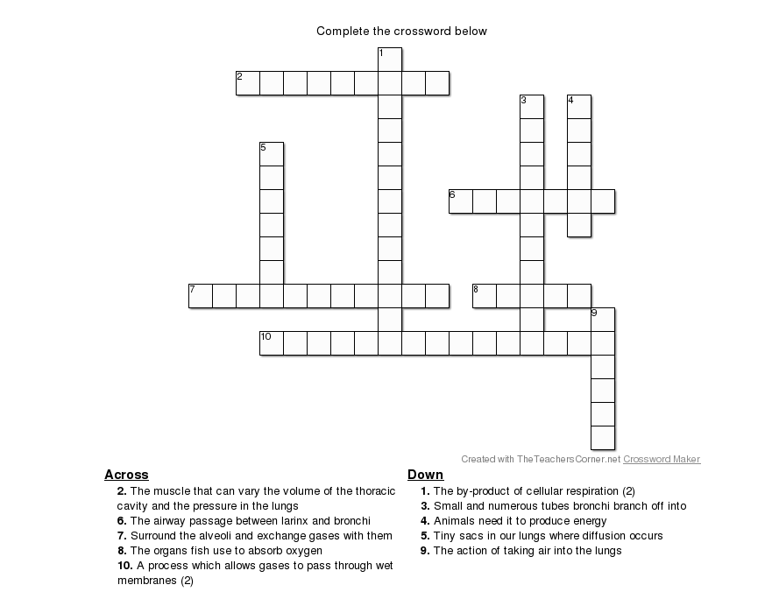
Then, working in groups, answer the following questions
- Which are the animals mentioned in the video that breath thanks to simple diffusion and the ones that need both simple diffusion and lungs or gill to respire?
- Why can’t we use simple diffusion instead of respiration to take in oxygen?
- How does the air enter and exit from our lungs?

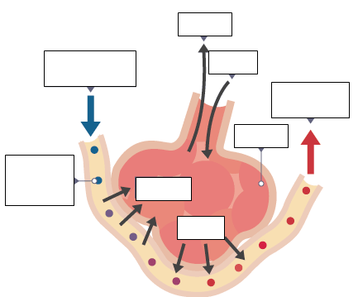
Label the drawing with the correct terms:
- DEOXYGENATED BLOOD IN
- OXYGENATED BLOOD OUT
- AIR OUT
- AIR IN
- RED BLOOD CELLS IN CAPILLARY
- CO₂ OUT
- O₂ IN

ACTIVITY 2
Read the text about circulatory pathways in vertebrates and complete the matching exercise.

Two different types of circulatory pathways are seen among vertebrate animals.
- Fishes have a single-loop system in which the heart only pumps the blood to the gills.
- The other vertebrates have a two-circuit (double-loop) circulatory pathway.
- In the systemic circuit, the heart pumps blood to all parts of the body except the lungs.
- The pulmonary circuit pumps blood to the lungs.
In amphibians and reptiles a single ventricle pumps blood in the pulmonary circuit to the lungs, and in the systemic circuit to the rest of the body.
Both oxygen-rich and oxygen-poor blood enter a single ventricle.
In some reptiles (i.e. crocodiles), birds and mammals, a septum completely separates the ventricles.
This means that these animals have a complete separation of the pulmonary and systemic circuits.
Good oxygen delivery is needed for their active way of life and the maintenance of a warm internal temperature.

In pairs match each circulatory pathway with the animal/s it belongs to.
Then in groups discuss your choice.

C
B
A
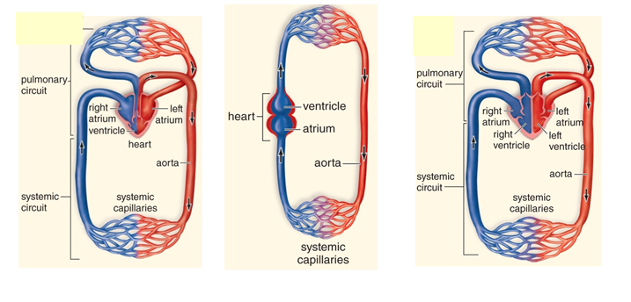

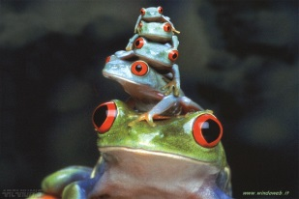
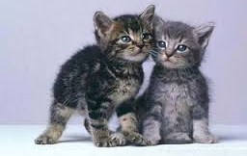
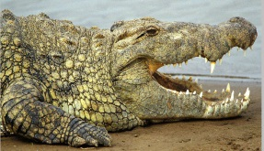
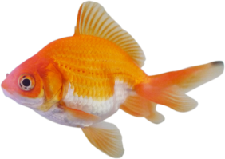
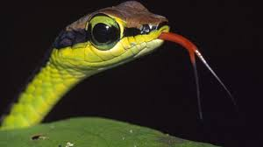
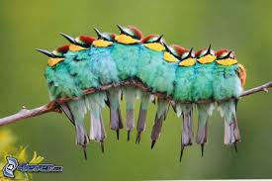

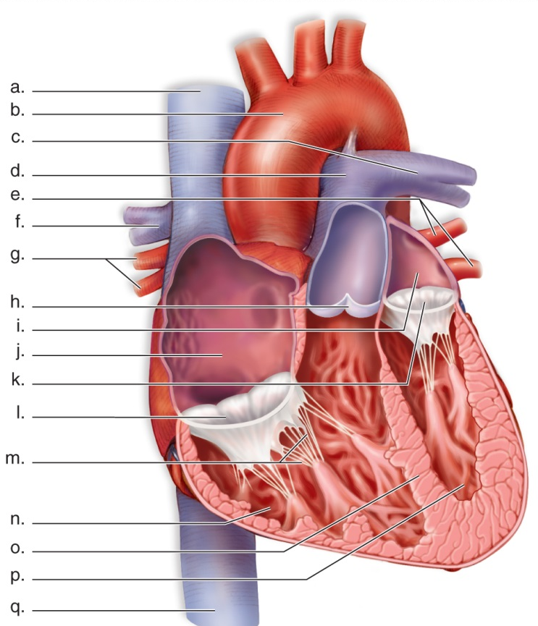
ACTIVITY 3 Label the diagram according to the given descriptions:
(c, f and m are not described; one of the definitions is not shown in the drawing)
- The septum divides the heart into left and right sides
- The right atrium is the upper, thin-walled chamber of the heart’s right side
- The left atrium is the upper, thin-walled chamber of the heart’s left side
- The right ventricle is the lower, thick-walled chamber of the heart’s right side
- The left ventricle is the lower, thick-walled chamber of the heart’s left side
- The tricuspid valve is between the right atrium and the right ventricle
- The bicuspid or mitral valve is between the left atrium and the left ventricle
- The pulmonary semilunar valve is between the right ventricle and the pulmonary trunk
- The aortic semilunar valve is between the left ventricle and the aorta
- The pulmonary trunk is the vessel that originates from the right ventricle and branches into the left and right pulmonary arteries
- The inferior and superior venae cavae carry the oxygen-poor blood from the tissues to the heart
- The aorta is the big vessel that originates from the left ventricle
- The left and right pulmonary arteries carry the oxygen-rich blood from the lungs to the heart

Fill the blanks
The strong, muscular heart has four …………………………
A ………………………… divides the heart into left and right sides.
The right side pumps oxygen-poor blood to the ………………………… and the left side
pumps oxygen-rich blood to the …………………………
Each side of the heart has two …………………………
The upper, thin-walled chambers are called ………………………… (sing., …………………………); they receive blood.
The lower chambers are the thick-walled right and left …………………………; they pump blood away from the heart.

Valves occur between the ……………… and the ………………, and between the ……………… and attached ………………
- The first ones are called the atrioventricular valves (…………………… and ……………… or mitralic).
- The second ones are called …………………… valves.

1. The ……………… ……………… receives blood from the superior and inferior venae cavae, returning oxygen-…………… blood from the tissues.
2. The blood passes through the atrioventricular valve into the …………… ………………… which pumps it through the pulmonary …………… …………… into the pulmonary trunk and pulmonary ………………. that take it to the …………….
3. The polmonary ………………… bring oxygen-……………… blood from the lungs to the ……………… …………………
4. After this blood passes through an atrioventricular valve, the ………………… ……………… pumps it through the ………..…… ……………… ……………. into the aorta, which takes it to the tissues.

CHEMISTRY: ISOTOPES
ACTIVITY 1 (PREVIOUS KNOWLEDGE)
Sentence unscramble: rearrange the words to build meaningful sentences
1) - and neutrons - in the nucleus - they are found - nucleons - because - protons - are sometimes called –
2) - particles - we use - the subatomic – masses - are so small - that in practice- the relative –
3) - is 1 - is 1/1840 - mass - of the electron - of the proton - the one - the relative - while -
4) - is 0.911 x 10⁻³⁰ - is 1.673 x 10⁻²⁷ - mass - of the electron - of the proton - the real - the one - very nearly 0
- while -
5) - while - to be +1 - the relative - so the charge - on an electron - on a proton - no charge - neutrons have - is taken - charge - is -1 -
6) - must be – and opposite - atom - because - in a neutral - in sign - in size – is equal - the number of electrons - the number of protons – the same as - their charge -
7) - up to the size - to blow up - the size - the nucleus will be - of a small marble– of a football stadium- if you imagine - an atom -
8) - between - of empty - space - the electrons - the nucleus and - there are - vast regions -

ACTIVITY 2 (PREVIOUS KNOWLEDGE)
Answer the questions
- What does the atomic number Z tell you about the element?
- Why do different elements have different atomic numbers?
- What does the mass number tell you about the atom?
- Why aren’t electrons included in the mass number?
- How do you calculate the number of neutrons in the atom of a particular element?
- How many neutrons does an atom with Z=17 and A=37 have?
- Find out Z and A of an atom which has 6 protons and 8 neutrons.
- Find out Z, A, number of protons and neutrons of this atom:

ACTIVITY 3
Answer the questions
- Which of these atoms (not their real symbols) is a pair of isotopes? Explain your answer.
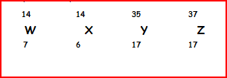

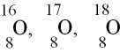
- Write the symbol with Z and A of two isotopes of chlorine, knowing that one has 18 neutrons and the other 20.
- Find out the number of protons and neutrons of these isotopes of oxygen:

ACTIVITY 4
Complete the mind map on the video (TED, Radioactive isotopes)
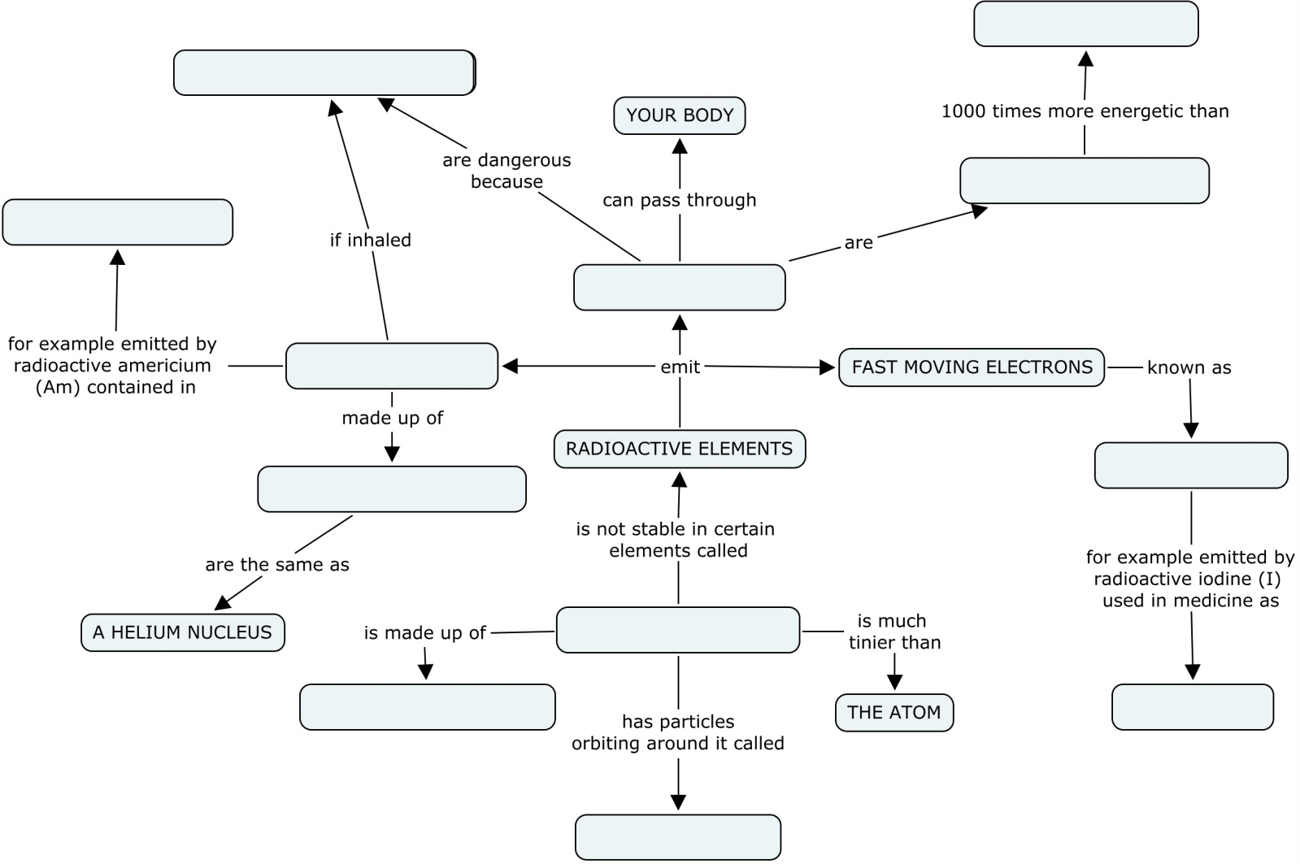

ACTIVITY 5
Look at the pictures in slide 62.
Read the text from Aqa chemistry, Lister-Renshaw, Nelson Thornes (Chapter 1, paragraphs 1.3, pg. 9).
Applying your knowledge about radioactive isotopes, answer the questions.
1. What is the half life of a radioactive isotope?
2. How long is the half life of C-14?
3. How does C-14 enter into our bodies?
4. If you measure the amount of C-14 in an old bone and you find that there is only 25% left, how old do you think your find is? Why?
5. Can you measure the age of an old golden ring using C-14 dating? Justify your answer.

EARTH SCIENCES

ACTIVITY 1
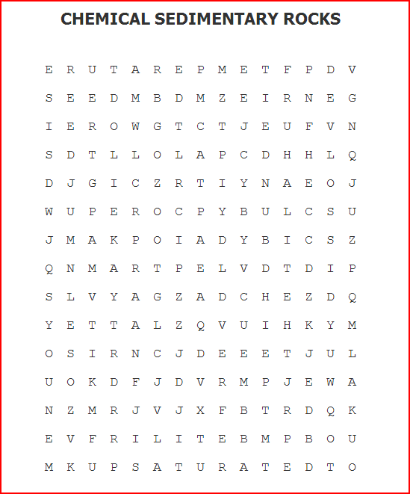
Chemical sedimentary rocks: read the text and complete with the missing words. You can find the same words in the key word puzzle.

Chemical sedimentary rocks form by ……………………..………… of minerals from water. This occurs when ………………………….. materials come out of water.
For example: take a glass of water and pour some salt (…………………) into it. The salt will dissolve into the water. If you set the water in a hot and dry place the water, but not the salt, will ………………………..away. In this way the concentration of salt gets higher and the water will eventually become …………………….. and will not be able to dissolve any more salt. At this point, as the water continues to evaporate, the salt will come out of solution and will be precipitated in the glass.
This is a common way for chemical sedimentary rocks to form and the rocks are commonly called……………………….. They are typically made up of the minerals halite (calcium chloride, or rock salt) and gypsum (calcium sulfate).
Another way to precipitate minerals out of water is to change the …………………..(or the acidity) of the water rather than evaporate the water. This is how rocks such as limestones form. Limestones commonly form in………………….., which do not evaporate away. For example, when cold sea water heats up, it can no longer hold as much calcium carbonate (……………………….., the mineral that limestones are made out of) in solution. When this happens, the calcium carbonate is precipitated out of the water, forming limestone. Limestones can also form from the shells of different sea critters that settle out on the bottom of the ocean.
So, when we find a limestone, we know that there was a large lake or ocean present at that location in the past. When we find evaporites, we can tell that we were probably in a hot and dry environment such as a desert playa.
(http://ratw.asu.edu/aboutrocks_chemicalsedimentary.html, ARIZONA STATE UNIVERSITY)

ACTIVITY 2
Organic sedimentary rocks: the formation of coal. The short paragraph below describes the formation of coal. Put the sentences in the right order to produce a coherent paragraph.

- Under high pressure and high temperature, dead vegetation was slowly converted to coal.
- This trapped the carbon in immense peat bogs that were eventually covered and deeply buried by sediments.
- Due to natural processes such as flooding, these forests were buried underneath soil.
- At various times in the geologic past, the Earth had dense forests in low-lying wetland areas.
- As the process continued the plant matter was protected from biodegradation and oxidation, usually by mud or acidic water.
- As more and more soil deposited over them, they were compressed. The temperature also rose as they sank deeper and deeper.
- As coal contains mainly carbon, the conversion of dead vegetation into coal is called carbonization.

